CCUF Management Group Meeting Minutes April 17, 2024

Attendees:

- *Brian Wood - Google
- *Kwangwoo Lee – HP
- Lachlan Turner - Lightship
- *Michael Vogel - atsec
- Miguel Bañón - Consultant
- *Mike Grimm - Microsoft
- *Petra Manche – Cisco
- *Matt Downey NIAP (Guest)
- *Angela Soum NIAP (Guest)
(*) In attendance

Agenda:

CCUF Workshops

- CCUF Spring Workshop April 22 -24 2024 –Actions:

Report:
- Virtual event
- Bill’s proposal to be discussed at workshop
- Joint session Tuesday 23rd afternoon

External Conferences

- ICCC 2024 – Nov 2 - 6, 2024 Qatar
Actions:
- PM to submit paper on behalf of new chair
- BW survey asking members attendance (point people to at Workshop)
Report:
- Unsure how many members are planning on attending

Website and OnlyOffice

- Moving from onlyoffice
Actions:
- BW to continue working
- BW to ask iTC Chairs to test site
Report:
- Moving to https://www.ccusersforum.org/
- BW & Fiona have spoken
- BW unsure on email working

Election
- Election
Actions:
- Need to decide on a date.
- Notify Members during the CCUF Workshop

Report:
- Voting will take place during a period of a minimum of one week, starting on Wednesday and ending no earlier than the following Tuesday in order to allow for enough time for all entities to vote. Specific start and end times for voting (including the time zone) will be announced by the CCUF MG. The announcement of the upcoming vote will be posted on the CCUF Forum. The announcement will be made at a minimum 6 weeks before the actual vote.
  - April 24 Announcement
  - June 11 Membership Tuesday Freeze
  - June 5 – June 11 (Wed – Tue) Candidate Nominations opens
  - June 12 - June 18 (Wed – Tue) Candidate Campaigning
  - June 19 - 25 (Wed – Tue) Voting
  - June 26 (Wed) Announcement

- Membership calls
Actions:

Report:
- Members call between Candidate Campaigning

Liaisons
- CCDB: (NIAP)
Actions:
Report:
  - Discussing published EUCC Implementation Act at CCDB meeting.
  - New AM for CCRA to add ALC_FLR to a certified product regarded as minor.
  - CCDB meetings next week main topic EUCC
  - More documents to be released on CC Portal
  - Office hours request to be re-organised or discontinued
- ISO (Kwangwoo Lee)
Actions:
Report:
- Progress of ISO/IEC 15408 and 18045 revisions
  - Next step : DIS (2024-06-01)
- Publication of ISO/IEC TS 9569:2023
  - ISO/IEC TS 95569: 2023 Information security, cybersecurity and privacy protection ─ Evaluation criteria for IT security ─ Patch Management Extension for the ISO/IEC 15408 series and ISO/IEC 18045
- ISO/IEC 19896 (3 parts) IT security techniques — Competence requirements for information security testers and evaluators (DIS, CD)
- Preliminary Work Item proposals
  - Evaluation of AI-based technology
  - Support for customized or multipurpose evaluation
- EU developments in the area of cybersecurity evaluation methodologies
EN 17640 “Fixed-time cybersecurity evaluation methodology for ICT products” and EN 17927 “Security Evaluation Standard for IoT Platforms”.
- Future meeting
The 84th ISO/IEC JTC 1/SC 27/WG 3 meeting /(30th September - 4th October 2024)

Collaboration Tools
- Only Office
Actions:
- PM, MV, KL Need to look at members numbers and start disabling members who have not accessed for a period of time.
- PM contacting Onlyoffice about the onlyoffice planned change.

Report:
- PM waiting for a response.
Management (members/storage/organization)
    - Storage space used: 16.97 / 50
    - Number of active users: 922/ 1000
  - Risk: No notification of the fee of storage space due.
Backup schedule
PM Performed backup on 2024-04-17 (being done weekly)

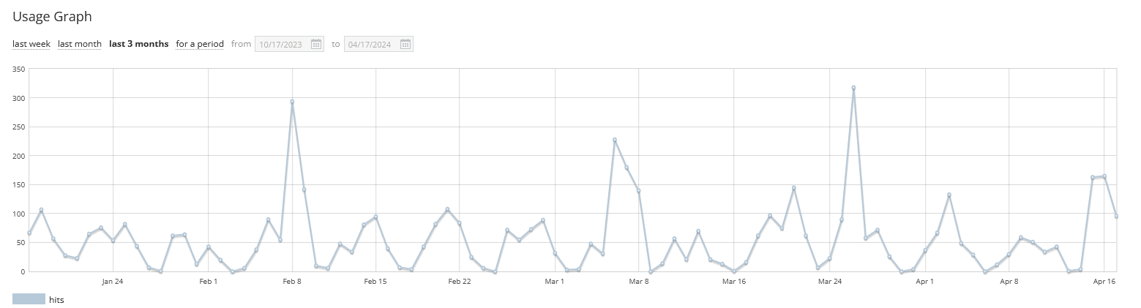

- Collaboration tool Report:

- Any Other Business

Next Meeting time:

- Next call CCUF MG May 15, 9 PT 10 CT, 12 ET, 5pm UK, 6pm Europe, midnight Korea
(Third Wednesday of the month)

