CCUF Management Group Meeting Minutes

March 20, 2024

Attendees:

- *Brian Wood - Google
- *Kwangwoo Lee – HP
- Lachlan Turner - Lightship
- *Michael Vogel - atsec
- Miguel Bañón - Consultant
- Mike Grimm - Microsoft
- *Petra Manche – Cisco
- *Matt Downey NIAP (Guest)
(*) In attendance

Agenda:

CCUF Workshops

- CCUF Spring Workshop April 22 -24 2024 –Actions:
- MD to confirm the time.
- Management Gp to start preparing workshop
- Announcement and survey to be sent out

Report:
- Virtual event
- Bill’s proposal to be discussed at workshop
- Joint session Tuesday 23rd afternoon 3pm

External Conferences

- EU CSA – March 11-13, Brussels, Belgium
Actions:

Report:
- Schedule published
- Plan for physical conference only.
- Mar 10 is International Crypto Day and AICYBERDAY

- ICCC 2024 – Nov 2 - 6, 2024 Qatar
Actions:

Report:
- Call for papers to open in April

- RSA – May 6-9, 2024, San Francisco
Actions:

Report:

- CSfC Day– May 7, 2024, Maryland
Actions:

Report:
- This is at the same time as RSA.
- There is a CC day on May 6

Communications/Outreach
- Newsletter
Actions:

Report:
- .

- Blogs/ CC External resources
Actions:
Report:
- Linked In “Common Criteria Professionals”
Actions:
Report:
- .
- CCUF website and CC Portal updates
Actions:

Report:

- Membership calls
Actions:
- MG - North America members call to discuss Bill’s proposal
Report:

Liaisons
- CCDB: (NIAP)
Actions:
Report:
  - Discussing published EUCC Implementation Act at CCDB meeting.
  - New AM for CCRA to add ALC_FLR to a certified product regarded as minor.
- ISO (Kwangwoo Lee)
Actions:
Report:
- Working with CCDB & CCMD. Received CC comments.
- 15408 and 18405 working draft under review and closes April 1.
- Miguel created xml file for CC:2022, working on ISO xml files (Part 2, 3 and CEM).
- WG meetings in April is virtual.
- Aim revised for standard end of 2024

Conferences & Events with expected CCUF involvement

Collaboration Tools
- Only Office
Actions:
- PM, MV, KL Need to look at members numbers and start disabling members who have not accessed for a period of time.
- PM contacting Onlyoffice about the onlyoffice planned change.

Report:
- PM waiting for a response.
Management (members/storage/organization)
    - Storage space used: 16.76 / 50
    - Number of active users: 920/ 1000
  - Risk: No notification of the fee of storage space due.
Backup schedule
PM Performed backup on 2024-03-20

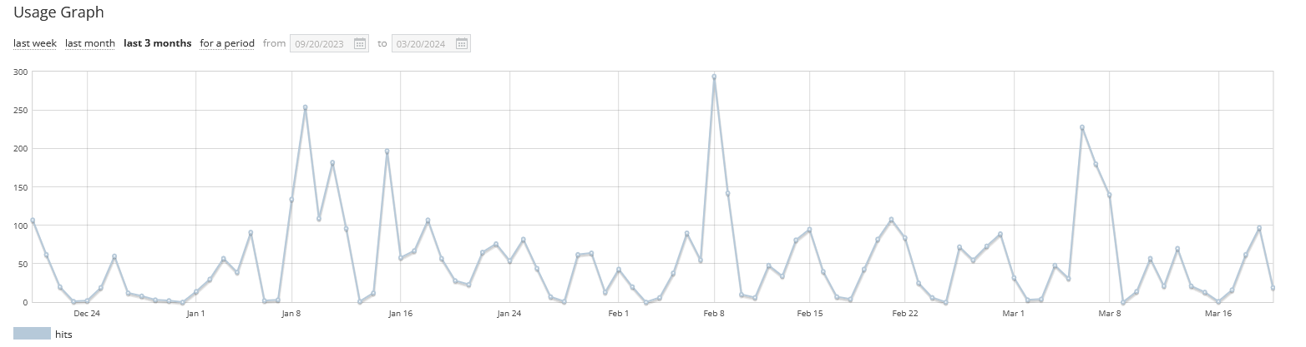

- Collaboration tool Report:

- Any Other Business
  - EUCC

Next Meeting time:

- Next call CCUF MG April 17, 9 PT 10 CT, 12 ET, 5pm UK, 6pm Europe, midnight Korea
(Third Wednesday of the month)

