CCUF Management Group Meeting Minutes

March 20, 2024

# Attendees:

* *Brian Wood - Google
* *Kwangwoo Lee – HP
* *Lachlan Turner - Lightship
* *Michael Vogel ‑ atsec
* *Miguel Bañón ‑ Consultant
* *Mike Grimm ‑ Microsoft
* *Petra Manche – Cisco
* *Matt Downey NIAP (Guest)

(*) In attendance

# Agenda:

## CCUF Workshops

* **CCUF Spring Workshop April 22 -24 2024 –Actions:**

**Report:**

* Virtual event
* Bill’s proposal to be discussed at workshop

## External Conferences

* **EU CSA – March 11-13, Brussels, Belgium**

**Actions:**

**Report:**

* Schedule published
* Plan for physical conference only.
* Mar 10 is International Crypto Day and AICYBERDAY
* **ICCC 2023 – Nov 2 - 6, 2024 Qatar**

**Actions:**

**Report:**

## Communications/Outreach

* **Newsletter**

**Actions:**

**Report**:

* .
* **Blogs/ CC External resources**

**Actions**:

**Report:**

* **Linked In “Common Criteria Professionals”**

**Actions:**

**Report:**

* .
* [**CCUF website**](http://ccusersforum.org) **and** [**CC Portal**](https://www.commoncriteriaportal.org/CCUF/) **updates  
  Actions:**

**Report:**

* **Membership calls**

**Actions:**

* MG - North America members call to discuss Bill’s proposal

**Report:**

## Liaisons

* **CCDB: (NIAP)  
  Actions:**

**Report:**

* + .
* **ISO (Kwangwoo Lee)**  
  **Actions:**

**Report:**

* Working with CCDB & CCMD. Received CC comments.
* 15408 and 18405 working towards a working draft.
* Miguel created xml file for CC:2022, working on ISO xml files (Part 2, 3 and CEM).
* WG meetings in April. Aim revised standard end of 2024

## Conferences & Events with expected CCUF involvement

## Collaboration Tools

* **Only Office**

**Actions:**

* PM, MV, KL Need to look at members numbers and start disabling members who have not accessed for a period of time.
* PM contacting Onlyoffice about the onlyoffice planned change.

**Report:**

Management (members/storage/organization)

* + - Storage space used: **15.91 / 50**
    - Number of active users: **920/ 1000**
  + Risk: No notification of the fee of storage space due.

Backup schedule

PM Performed backup on **2024-03-20**

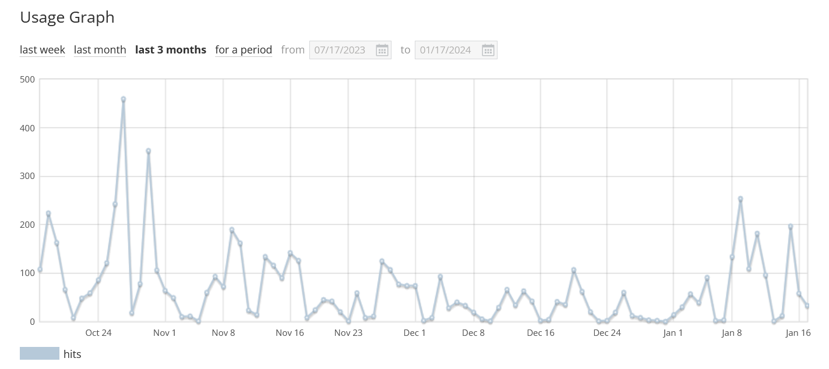

* **Collaboration tool Report:**
* **Any Other Business**
  + EUCC

Next Meeting time:

* Next call CCUF MG 21 February 2024, 9 PT 10 CT, 12 ET, 5pm UK, 6pm Europe, midnight Korea

(Third Wednesday of the month)