CCUF Management Group Meeting Minutes May 15, 2024

Attendees:

- *Brian Wood - Google
- Kwangwoo Lee – HP
- *Lachlan Turner - Lightship
- *Michael Vogel - atsec
- Miguel Bañón - Consultant
- *Mike Grimm - Microsoft
- *Petra Manche – Cisco
- *Matt Downey NIAP (Guest)
- *Angela Soum NIAP (Guest)
(*) In attendance

Agenda:

CCUF Workshops

- CCUF Fall Workshop October 2024 –Actions:

Report:
- Registration is open

External Conferences

- ICCC 2024 – Nov 2 - 6, 2024 Qatar
Actions:
- BW survey asking members attendance (point people to at Workshop)
Report:
- Unsure how many members are planning on attending
- PM submitted paper on behalf of the chair
- Papers close on May 21
- Next planning meeting May 21

Website and OnlyOffice

- Moving from onlyoffice
Actions:
- BW to continue working
- BW to ask iTC Chairs to test site
Report:
- Moved to https://www.ccusersforum.org/

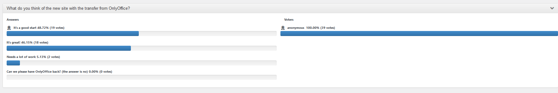

Election
- Election
Actions:

Report:
- Voting will take place during a period of a minimum of one week, starting on Wednesday and ending no earlier than the following Tuesday in order to allow for enough time for all entities to vote. Specific start and end times for voting (including the time zone) will be announced by the CCUF MG. The announcement of the upcoming vote will be posted on the CCUF Forum. The announcement will be made at a minimum 6 weeks before the actual vote.
  - April 24 Announcement
  - June 10 Membership Tuesday Freeze
  - June 5 – June 11 (Wed – Tue) Candidate Nominations opens
  - June 12 - June 18 (Wed – Tue) Candidate Campaigning
  - June 19 - 25 (Wed – Tue) Voting
  - June 26 (Wed) Announcement

- Membership calls
Actions:

Report:
- Members call between Candidate Campaigning

Liaisons
- CCDB: (NIAP)
Actions:
Report:
  - New AM for CCRA to add ALC_FLR to a certified product regarded as minor.
  - More documents to be released on CC Portal
  - Discussed proposals for Office hours to be organized, Nations to register and sign up. Announce head of time. Layout to be structured. CCUF members could also make specific nations request.
  - CCDB application from nation for consuming participant, going to 33. Interest from 2 other nations.
  - Discussions with ENISA and EU on Implementation Act and are continuing.
  - MD to join ITC Chairs call to discuss TDs.

- ISO (Kwangwoo Lee)
Actions:
Report:
- Progress of ISO/IEC 15408 and 18045 revisions
  - Next step : DIS (2024-06-01)
- Publication of ISO/IEC TS 9569:2023
  - ISO/IEC TS 95569: 2023 Information security, cybersecurity and privacy protection ─ Evaluation criteria for IT security ─ Patch Management Extension for the ISO/IEC 15408 series and ISO/IEC 18045
- ISO/IEC 19896 (3 parts) IT security techniques — Competence requirements for information security testers and evaluators (DIS, CD)
- Preliminary Work Item proposals
  - Evaluation of AI-based technology
  - Support for customized or multipurpose evaluation
- EU developments in the area of cybersecurity evaluation methodologies
EN 17640 “Fixed-time cybersecurity evaluation methodology for ICT products” and EN 17927 “Security Evaluation Standard for IoT Platforms”.
- Future meeting
The 84th ISO/IEC JTC 1/SC 27/WG 3 meeting /(30th September - 4th October 2024)

Collaboration Tools
- Only Office
Actions:

Report:
Management (members/storage/organization)
    - Storage space used: 16.97 / 50 OnlyOffice
    - Number of active users: 922/ 1000 OnlyOffice
Management (members/storage/organization)
    - Number of active users: 888 (a number onlyoffice emails bounced)

Backup schedule

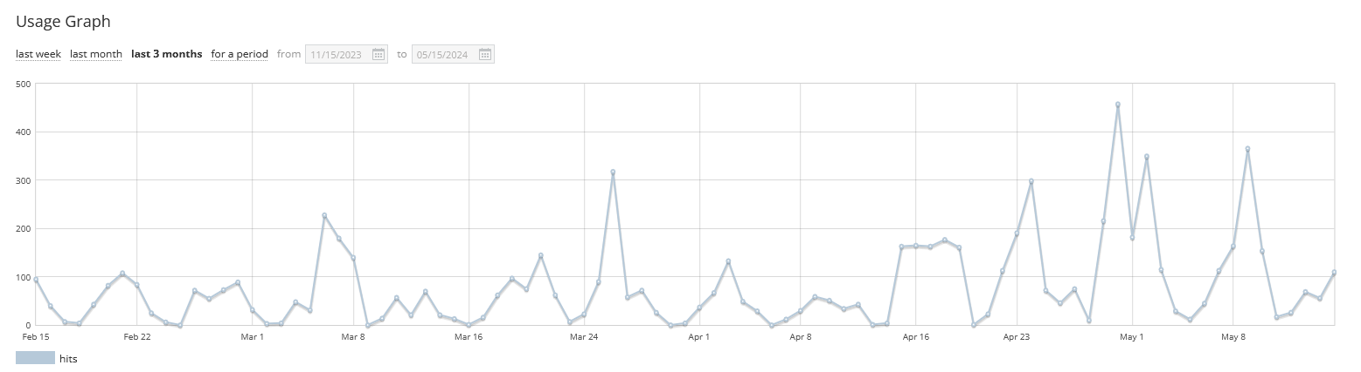

- Collaboration tool Report:

- Any Other Business

Next Meeting time:

- Next call CCUF MG June 12, 8 PT 9 CT, 11 ET, 4pm UK, 5pm Europe, midnight Korea
(Third Wednesday of the month)

